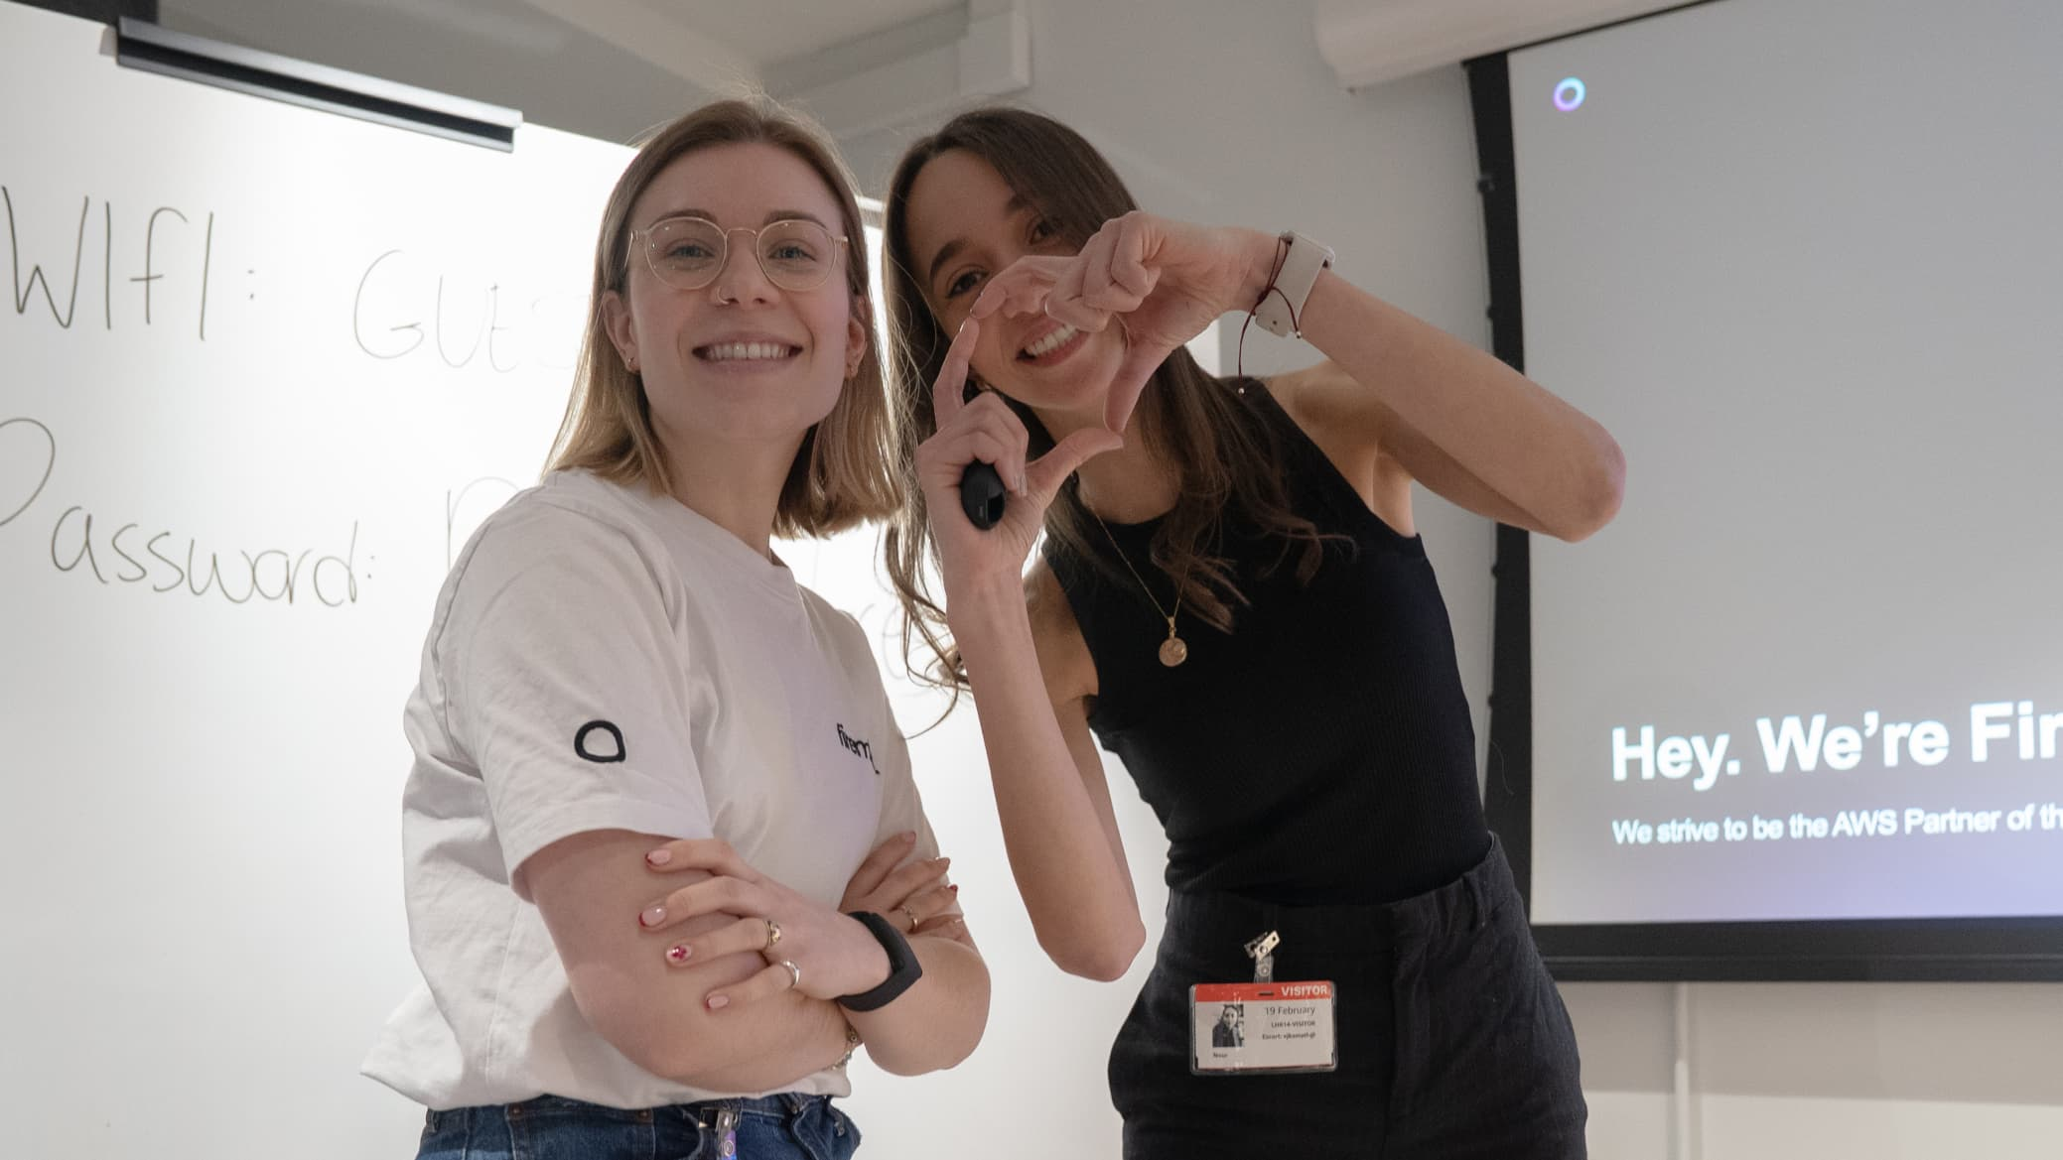

# **AI/ML Engineer**

📍 Location: UK, Finland (Hybrid)  
 🕒 Full Time  
 💡 Generative AI | AWS

## **About Firemind**

Firemind is a specialist in Generative AI and Data Modernisation and an AWS Premier Partner. We help our clients take ideas from concept to production by building scalable AI and cloud solutions that solve real business challenges.

We were recently recognised at the AWS GenAI Innovation Awards, placing just after Nvidia - this was a big milestone for our small and focused team!

## **The Role**

As an AI/ML Engineer, you’ll work on real client projects as part of Firemind’s Professional Services team. Your role will focus on designing and building practical machine learning solutions that deliver real value. You’ll use your experience in data analysis, modelling, and cloud platforms to help solve complex problems in production settings.

You’ll be part of a collaborative and senior-level team where continuous learning, shared ownership, and real-world results matter.

## **What you’ll do**

* Analyse large datasets to uncover trends, patterns, and insights.
* Design the architecture of solutions from a software development perspective.
* Design, build, and deploy scalable AI/ML models in production environments to aid clients in making informed decisions.
* Implement feature engineering, model tuning, and hyperparameter optimization.
* Ensure data governance, security, and ethical AI principles in model development
* Apply cutting-edge techniques in generative AI, large language models (LLM), and prompt engineering.
* Collaborate closely with engineers, architects, and customers to deliver high-quality solutions.
* Present results in a clear, actionable manner through data and visualisations.

## **What we’re looking for**

✅ Solid experience in machine learning and data analysis.  
✅ Strong programming skills in Python and hands-on experience with AWS services (e.g. S3, Lambda, SageMaker)  
✅ Experience with Generative AI Models, including building, fine-tuning, and deploying generative models. Familiarity with agents, their frameworks, and RAG (Retrieval-Augmented Generation)

✅ Experience with deploying and scaling LLM in production environments, handling latency, cost optimisation, and integration within existing systems.

✅ Familiarity with orchestrating LLM pipelines using existing AI frameworks.

✅ Deep understanding of Natural Language Processing (NLP) techniques like transformer models, attention mechanisms, tokenization, and embeddings.

✅ Ability to work in customer-facing environments and translate needs into working ML systems.  
✅ Strong communication and collaboration skills.

## **Nice to have**

## ➕ Degree in Computer Science, Data Science, or related field ➕ AWS certifications (Associate, Professional, or Specialty) ➕ Knowledge of **Reinforcement Learning**, especially in how it applies to decision-making models ➕ Experience with **Computer Vision** models and frameworks, including CNNs and GANs ➕ Experience working in B2B or consulting environments ➕ Familiarity with DevOps or MLOps practices.

## **Why join Firemind**

🔥 Work on real AI solutions with real-world impact  
 🌍 Hybrid and remote flexibility with team hubs in the UK and Finland  
 🧠 Collaborate with skilled engineers in a low-ego, high-impact environment  
 🚀 Flat structure where your ideas are heard and you can shape your role  
 🇫🇮 Be part of growing Firemind’s presence in Finland and influence how we work locally

## **How to Apply**

If you're an AI/ML engineer ready to build production-level solutions that make a difference, we'd love to hear from you.

Send your CV and a short note or LinkedIn profile link to [**hiring@firemind.com**](mailto:hiring@firemind.com)

At Firemind, we build useful AI with great people. Let’s talk.

For any enquiries, feel free to contact:  
📩 Maureen Chan-Nieminen – Maureen.chan-nieminen@firemind.com

At Firemind, we build useful AI with great people. Let’s talk.