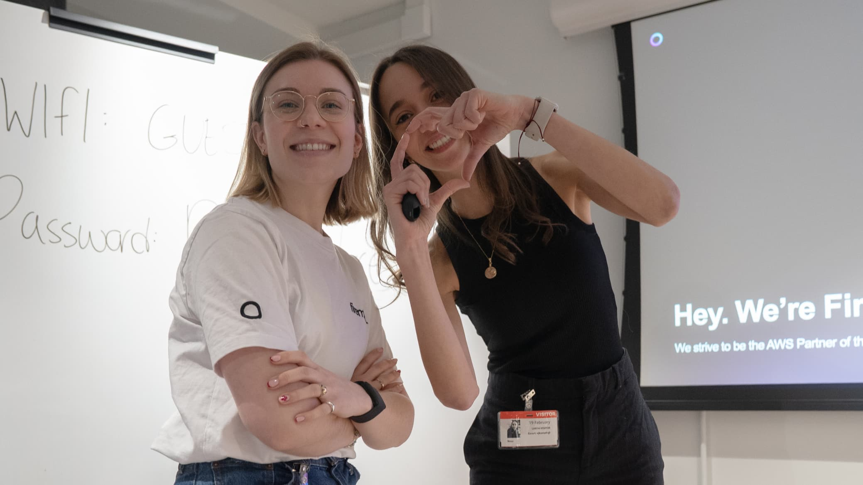

# **AI/ML Engineering Lead**

📍 Location: UK, Finland (Hybrid)  
 🕒 Full Time  
 💡 Generative AI | AWS | Team Leadership

## **About Firemind**

Firemind is a specialist in Generative AI and Data Modernisation and an AWS Premier Partner. We help our clients take ideas from concept to production by building scalable AI and cloud solutions that solve real business challenges.

We were recently recognised at the AWS GenAI Innovation Awards, placing just after Nvidia - this is a big milestone for our small and focused team!

## **The Role**

We’re looking for **an AI/ML Engineering Lead** to manage and support our AI and machine learning team. This role combines hands-on technical work with people leadership. You’ll guide a group of skilled engineers, support their development, and work directly on client-facing projects within our Professional Services team.

You’ll play a key role in solving real-world problems with AI, working with customers across different industries. As we grow internationally, this role also gives you the chance to shape how we scale and operate, particularly as we expand our presence in Finland.

## **Key Responsibilities**

### **Team leadership and development**

* Manage and support a team of AI/ML engineers through regular 1:1 meetings and coaching.
* Help the team stay focused, balanced, and aligned with project goals.
* Spend approximately 1.5 days per week on leadership duties such as planning, mentoring, and team development.

### **Technical work and delivery (approximately 3.5 days/week)**

* Work with Firemind’s Professional Services team to design and deliver client-facing AI and ML solutions.
* Build production-ready systems using Python, AWS, and modern machine learning frameworks.
* Collaborate with data engineers, solution architects, and customer teams to understand business needs and deliver high-impact outcomes.
* Guide internal technical practices and contribute to reusable assets and tools.
* Explore and apply the latest in AI, including generative models and prompt engineering.

**What We’re Looking For**

✅ Solid experience as an AI or ML Engineer or Data Scientist, including leading technical projects  
✅ Experience delivering AI or ML solutions in client-facing or consulting settings  
✅ Strong programming skills in Python and familiarity with AWS services such as S3, Lambda, and SageMaker  
✅ Experience with **Generative AI Models**, including building, fine-tuning, and deploying generative models  
✅ Deep understanding of **Natural Language Processing (NLP)** techniques like transformer models, attention mechanisms, tokenization, and embeddings  
✅ Experience mentoring or leading team members  
✅ Strong communication skills, with the ability to explain technical concepts clearly to both technical and non-technical audiences.

## **Nice to Have**

➕ Degree in Computer Science, Data Science, or a related field  
➕ AWS certifications (Associate, Professional, or Specialty)  
➕ Knowledge of Reinforcement Learning, especially in how it applies to decision-making models  
➕ Experience with Computer Vision models and frameworks, including CNNs and GANs, particularly for image data use cases  
➕ Experience working in B2B or consulting environments  
➕ Familiarity with DevOps or MLOps practices

## **Why Join Firemind**

🔥 Work on real AI solutions with practical impact  
 🌍 Flexible hybrid or remote work with hubs in the UK and Finland  
 🧠 Collaborate with experienced engineers in a low-ego, high-skill environment  
 🚀 Flat structure where your ideas are heard and experimentation is encouraged  
 💥 Work closely with AWS and stay ahead in applied AI  
 ��🇮 Be part of building Firemind’s presence in Finland and help shape how we operate and grow locally

## **How to Apply**

If you're an AI /ML engineer ready to lead meaningful, client-facing projects, we'd love to hear from you!  
  
 **Send your CV and a short note or LinkedIn profile link to** [**hiring@firemind.com**](mailto:hiring@firemind.com)For any enquiries, feel free to contact:   
📩 Maureen Chan-Nieminen - Maureen.chan-nieminen@firemind.com

At Firemind, we build useful AI with great people. Let’s talk.